Contents

**Day1 4**

1.1 TIME BOXING: 4

1.2 EMAIL USAGE AND MAIL ATTACHMENTS: 4

1.3 CALENDAR AND CREATING MEETINGS: 5

1.4 HANGOUTS: 5

1.5 MEETING INVITATIONS: 5

1.6 OUTLOOK: 6

1.7 MS WORD: 6

1.8 FILE NAMING CONVENTIONS: 6

1.9 GOOGLE DRIVE: 6

**Day2 8**

2.1 Ms-Excel 8

2.1.1 Basics of Excel 8

2.1.2 Entering Data 8

2.1.3 Insert rows and columns. 8

2.1.4 Merge and unmerge 8

2.1.5 Group and ungroup of rows and columns 8

2.1.6 Freeze and Unfreeze of data. 8

2.1.7 Insert Formulas 8

2.1.8 Inserting Graphs and charts 8

2.1.9 Sorting 8

3.SRM Project Plan PPT 9

4.Manager Expectations PPT 9

4.1 Daily Activities: 9

4.2 Design Document Preparation for SW: 9

**Day3 10**

5.MS PPT 10

5.1 fishbone diagram 10

6. 7 Basic Productivity tools 11

6.1 Fishbone Diagram 11

6.2 check sheets 11

6.3 Pareto Chart 12

6.4 Scatter Plot: 12

6.5 Histogram: 13

6.6 control Charts 13

6.7 flow chart 14

7. SDLC 14

8. 4 Blocker PPT: 16

**Day 4 17**

9.Defect Matrix 17

10.DSO (Digital Storage Oscilloscope): 17

10.1 Waveforms Measurement: 18

10.2 V/T Scaling 18

10.3 Trigger 18

11.ESD (Electrostatic Discharge): 18

Safety For HV , HC: 18

**Day 5: 19**

12.Root Cause Analysis: 19

13.Practical Explanation of DSO: 20

14.Lab Equipment: 21

14.1 Digital Multimeter: 21

14.2 Variac: 21

14.3 Isolation Transformer: 21

14.4Regulated Power Supply 22

14.5 Function Generator 22

15. GIT: 22

Index**:**

| **S.No** | **Topic to Study** | **Study start date** | **Study end date** | **Status** |
| --- | --- | --- | --- | --- |
| 1 | Time BoxingEmailUsage and MailAttachments,  Calendar and Creating Meetings,Hangouts,  Outlook,MS Word,  FilenamingConventions,Google Drive,StudyDocument | 17/10/2023 | 18/10/2023 | completed |
| 2 | MS Excel | 19/10/2023 | 19/10/2023 | completed |
| 3 | SRM Project Plan PPT | 19/10/2023 | 19/10/2023 | completed |
| 4 | Managers expectations ppt | 19/10/2023 | 19/10/2023 | completed |
| 5 | MS PPT | 20/10/2023 | 20/10/2023 | completed |
| 6 | Basic Quality tools | 20/10/2023 | 20/10/2023 | completed |
| 7 | SDLC | 20/10/2023 | 20/10/2023 | completed |
| 8 | 4 Blocker ppt | 20/10/2023 | 20/10/2023 | completed |
| 9 | Defect matrix | 23/10/23 | 23/10/23 | completed |
| 10 | DSO | 23/10/23 | 25/10/23 | completed |
| 11 | ESD,Safety forHC,HV | 23/10/23 | 23/10/23 | completed |
| 12 | RCA | 25/10/23 | 25/10/23 | completed |
| 13 | Practical Explanation of  DSO | 25/10/23 | 25/10/23 | completed |
| 14 | Lab equipment usage | 25/10/23 | 25/10/23 | completed |
| 15 | Git | 25/10/23 | 25/10/23 | completed |
|  |  |  |  |  |

# 

# Day1

**Date:17/10/23**

## 1.1 TIME BOXING:

Time Boxing is the process of scheduling the time for a certain period. Which will describe how much time it requires to complete every task.

Example:

Good Morning Sir,This is Pavithra

Task planning @18/10/2023,

1) Mail Chaining ------10:00am to 11:00 am.

2) Outlooks ------11:00am to 12:00pm.

3) file naming conventions------12:00pm to 1:20pm

4) Meeting time------2:00pm to 2:20pm

5) MS Word

a. Understanding doc with index,text format------2:20 pm to 3:30pm

b. header, footer,page no------3:30pm to 4:30pm

c. preparing study document------4:30pm to 5:30pm

6) Google drive------5:30pm to 7:00pm

## 1.2 EMAIL USAGE AND MAIL ATTACHMENTS:

Generally, we are all using mail but additionally it contains Hangouts and Chats. If we are preparing any type of documents like word, excel we need to attach the file through the mail.

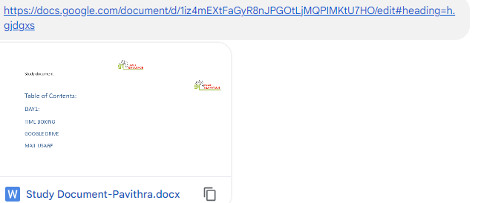

## 1.3 CALENDAR AND CREATING MEETINGS:

Calendar is the pre-planning tool. It will intimate the meeting time and remind the schedules, through this calendar we can plan a meeting and create a meeting. It always reminds me of the duties at that time.

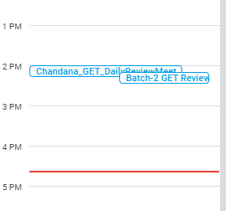

## 1.4 HANGOUTS:

Hangouts are nothing but the chat folders . It will describe how many of them contact each other.If it contains the green color then it shows that that contact is in active state.

## 1.5 MEETING INVITATIONS:

Meeting invitations is nothing but we have already created a meeting link in the calendar that is going to be shared on gmail, to another also invited and joined through this link.

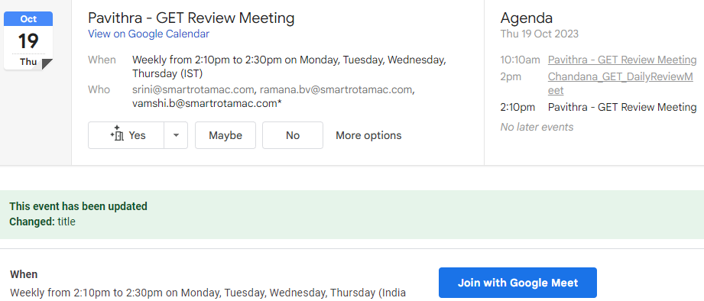

**Date:18/10/2023**

## 1.6 OUTLOOK:

Outlook is another type of exchanging information from email to email. It is the same as gmail, but so many professionals and technical people prefer Outlook to share the technical information.

## 1.7 MS WORD:

MS word is used to create the document. MS Word is also used for studying documents. It contains certain design rules for creating a document. By this tool i learned these topics

a. Understanding doc with index,text format

b. header, footer,page no

c. preparing study document

## 1.8 FILE NAMING CONVENTIONS:

File naming convention is the naming concept.Which will describe the giving related names or shortcut names to the files.

for example, System Design Document→SDD

## 1.9 GOOGLE DRIVE:

Google Drive is used to create different types of files that allows you to create and edita variety of files like documents,spreadsheets,presentations.

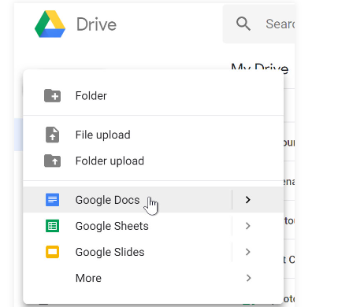

**1.10 STUDY DOCUMENT:**

Study document describes what we have done and learned and whether it will practically work or not.

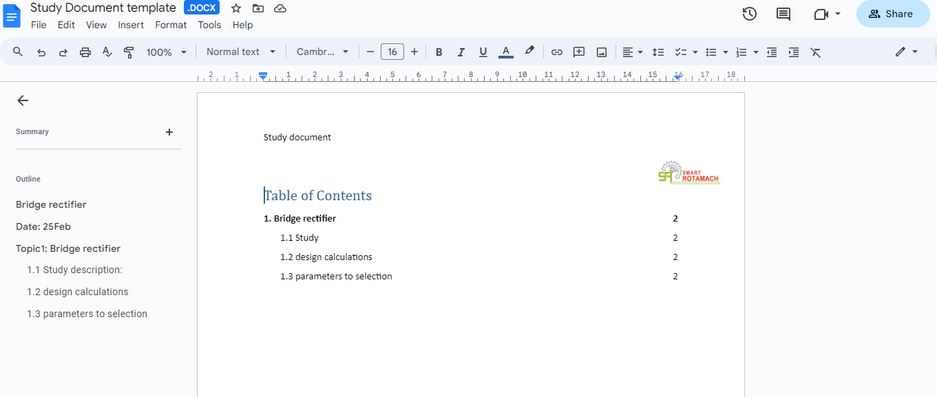

# Day2

## 2.1 Ms-Excel

It is referred to as a large sheet of paper with columns and rows that allows writing in an organized way.

### 2.1.1 Basics of Excel

* Adding sheets, renaming sheets, deleting sheets, Zooming option.

### 2.1.2 Entering Data

* Navigation Keys
* Auto Complete
* Ctrl+up arrow/Home—>First filled cell
* Ctrl+Down arrow/End—>Last filled Cell
* Shift+Down arrow—>select columns,Shift+Up arrow—>deselect
* Shift+Right arrow—>select rows,Shift+left arrow—>deselect

### 2.1.3 Insert rows and columns.

* Right click and select insert to add column and rows
* Select and right click and then delete we can delete rows and columns
* Select and press shift then mouse click to select all keys.

### **2.1.4 Merge and unmerge**

* By using merge and center option we can merge and unmerge cells
* It can merge two or more elements.

### 2.1.5 Group and ungroup of rows and columns

* By using group and ungroup options we can hide and unhide the data in rows and columns.

### 2.1.6 Freeze and Unfreeze of data.

* By using the freeze panes option we can freeze the first column and first row.
* Similarly, we can unfreeze the data.

### 2.1.7 Insert Formulas

By using = operator we can insert the formulas and after = operator we can assign any operation like (sum,average,count etc.).Then it gives the output.

### 2.1.8 Inserting Graphs and charts

* After selecting columns and rows for creating bar graphs and charts then select alt+F1 and then go to insert ribbon and select graph

### **2.1.9 Sorting**

* For sorting data go to home ribbon and select sort filter then we can filter data A-Z or Z-A or highest to lowest or lowest to highest.

## 3.SRM Project Plan PPT

G Drive link for project plan based on college project

[project plan .xlsx](https://docs.google.com/spreadsheets/d/1FpIIm91Hc4_qmwgmIlR7v63mC8eJ09Pf/edit#gid=262640827)

## 4.Manager Expectations PPT

* Design document Preparation and review
* Sample project study
* SW Design
* Resolve the issues and bugs
* detail information about day to day activities
* Excel format for defect matrix

### **4.1 Daily Activities:**

Timeboxing,MOM, Document Update,,GIT,Def matrix,EOD.

### **4.2 Design Document Preparation for SW:**

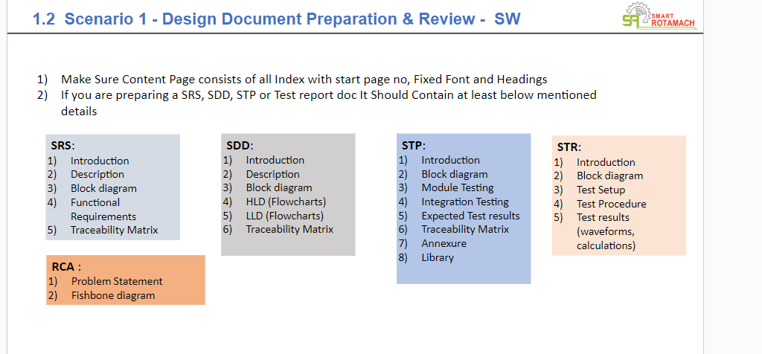

## 

# Day3

## 5.MS PPT

* By using Insert ribbon we can add pictures, shapes, text boxes…etc
* By using format ribbon we can change the format.
* We can change font and font color in home ribbon.
* Drawing a fishbone diagram using PPT is done.

### 5.1 fishbone diagram

* Fishbone diagram helps to find the root cause of the problem.
* To Resolve the problem for the first time.

Steps for fishbone diagram:

1. State the problem.
2. Define your Category.
3. Brainstorm each category.
4. Analyze the problem.

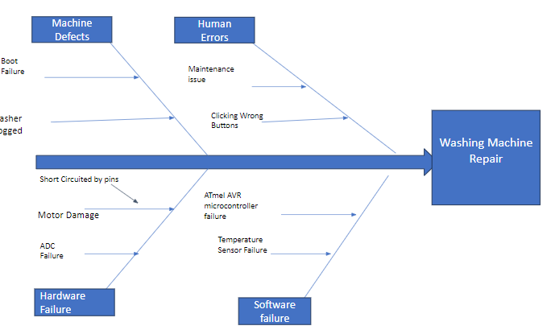

G-drive link for Fishbone diagram ppt

[washingmachine.pptx](https://docs.google.com/presentation/d/1H6aFbaeGrlc9ibAERRxIeYmTLSN0m7mU/edit#slide=id.p1)

## 6. 7 Basic Productivity tools

* Fishbone diagram
* Check Sheets
* Pareto Chart
* Scatter Plot
* Histogram
* Control Charts
* Flow Charts

### 6.1 Fishbone Diagram

* This method is used to find out the RCA.
* It helps to find out the roots of a problem.

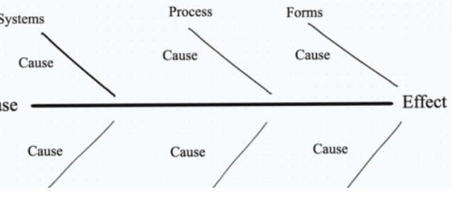

### 6.2 check sheets

It is used to collect data in easy a format.The data should be collected from the same person or location.Which is a understandable table and we get information quickly. 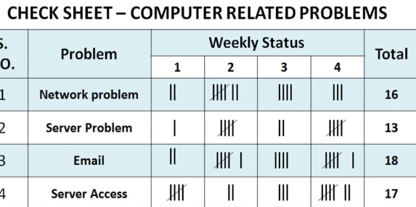

### **6.3 Pareto Chart**

Pareto is a chart that contains both bar chart and line chart. Individual values are represented in the bar chart and cumulative total is represented in the line chart.

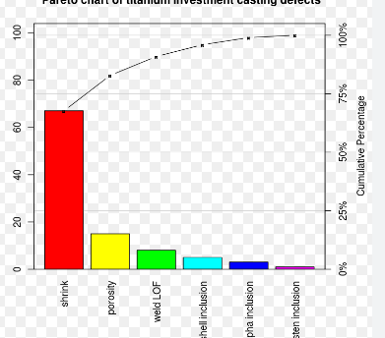

### **6.4 Scatter Plot:**

The purpose of the scatter plot is to display what happens to one variable when another variable is changed.

Scatter plots are the graphs that present the relationship between two variables in a data-set.

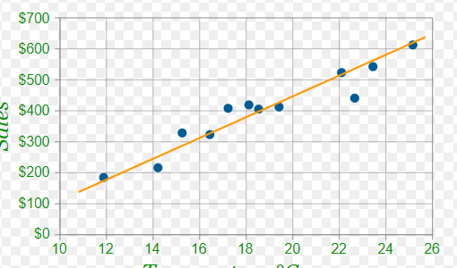

### **6.5 Histogram:**

Histogram is a bar graph representing the frequency distribution.

* A bar graph is the graphical representation of data using rectangular bars where the length of each bar is proportional to the value they represent.
* A histogram is the graphical representation of data where data is grouped into continuous number ranges and each range corresponds to a vertical bar.

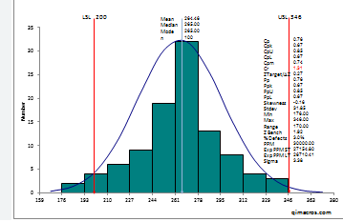

### **6.6 control Charts**

The control chart is a graph used to study how a process changes over time.

* By using this, we can conclude whether the process is in control or out of control by giving the limits.

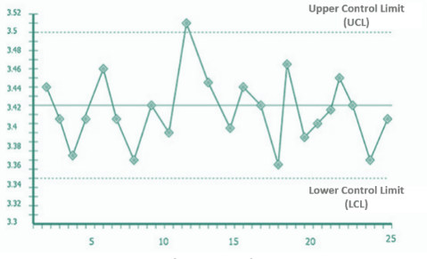

### **6.7 flow chart**

A flowchart is a picture of the separate steps of a process in sequential order

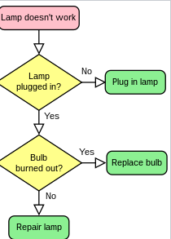

## 7. SDLC

Software Development Life Cycle (SDLC) is a process used by the software industry to design, develop and test high quality softwares. The SDLC aims to produce a high-quality software that meets or exceeds customer expectations, reaches completion within times and cost estimates .

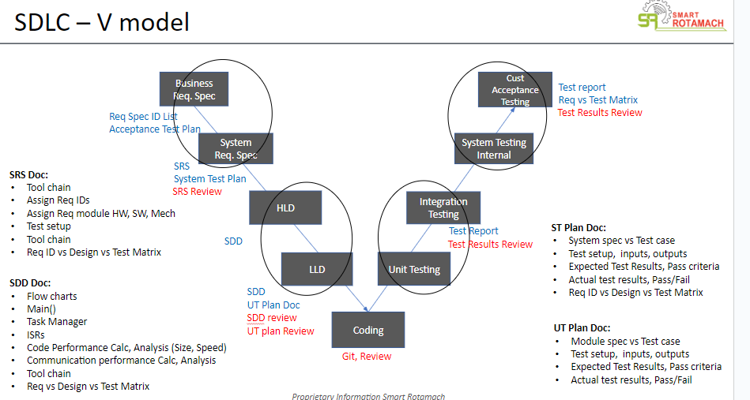

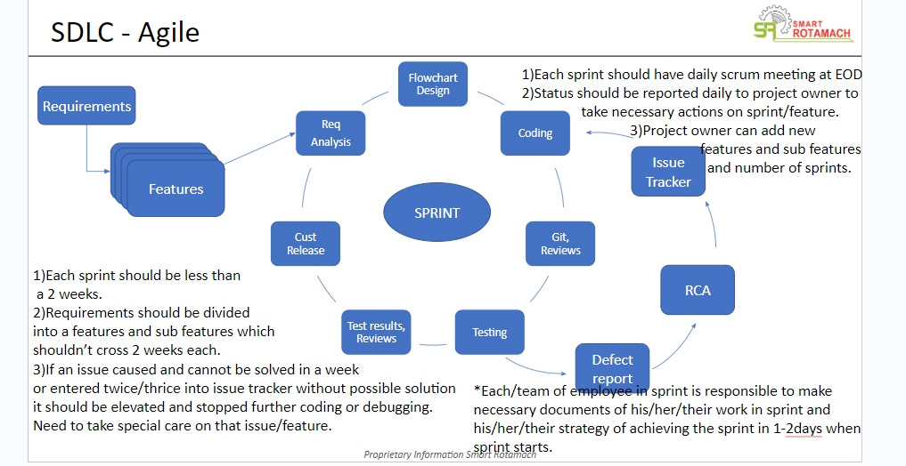

Study Flow of SDLC

SRS—SDD—STP— STR

SPRINT: A dedicated period of time in which a set of work will be completed

Defect Management Process:

Report any defect before the customer detects it.

Defect Discovery,Report defect,Accept Defect

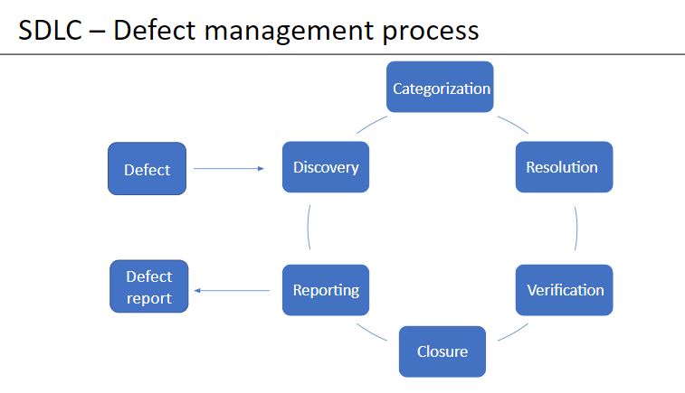

## 8. 4 Blocker PPT:

* The main theme of the 4 Blockers ppt is to get high-level understanding of the project.
* A four blocker provides a summary of the most important areas of a project.

1) a description of what's the scope of the project (**WHAT**)

2) a list of the milestones achieved (**ACHIEVEMENTS**)

3) a summary of the risks and the opps you have identified and you are managing with the team (**SPOTLIGHT**)

4) an outlook on the next milestones (**WHAT'S NEXT**).

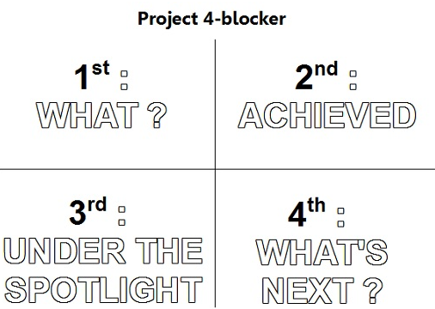

# Day 4

## 9.Defect Matrix

**SRM Defect Matrix**

It is a worksheet which is used to find the defects. This worksheet consists of different fields. Those are:

1. **Defect number :** It is a unique number given to defect.
2. **Date created :** It describes the date on which the defect is created.
3. **Defect created :** It represents the name of the person who created defect
4. **Defect found :** It represents the name of the person who found the defect
5. **Severity :** It describes the level of defect. It consists of

* **Catastrophic** : Causes failure to the injury
* **Major :** Causes product failure
* **Minor :** May cause failure
* **Cosmatic :** No effect on product performance

1. **Root cause :** It states the cause of defect
2. **Priority :** It describes the impact of a defect in the project. It consists of

* **High** ( It is very important, without resolving this defect the project cannot success)
* **Medium** ( It is important to project success, but a work around exists)
* **Low** ( If the defect is not resolved there is a little impact on project success)

1. **Owner :** It is the name of a person who has to resolve the defect
2. **Assigned Date :** It describes on which date the defect was assigned to resolve the defect.
3. **Status :** It describes the status of the defect . i.e: New , In progress, under review, completed
4. **Resolution :** It gives brief description of the defect resolution.

## 10.DSO (Digital Storage Oscilloscope):

Digital Storage Oscilloscope is a digital storage device that is used to convert any type of signals into digital form.And it also stores the non repetitive signals.

Oscilloscope contains different factors those are:

* **Input channels :** These are used to connect the probes
* **Volts/div :** Used to calculate the amplitude of the signal
* **Time/Div :** Used to calculate the frequency of the signal
* Screen with grid
* **Vertical position/offset :** Used to move the waveform in Y- direction.
* **Horizontal position/ offset :** Used to move the waveform in X- direction.
* **Trigger level :** Used to stabilize the waveform.
* **Mode settings**

1. Single mode : Captures signal once at a time.
2. Normal mode : Captures signal when changes occured.
3. Auto mode : Captures signal continuously at Run time.

### 10.1 Waveforms Measurement:

### 10.2 V/T Scaling

* By adjusting V/T Scaling, we can increase or decrease the resolution of the waveforms.
* The visibility of the waveforms are very clear and efficient.
* It enables the zoom in and out of the signal and we can clearly observe the variations of the signal.

### 10.3 Trigger

* Triggering in a Digital Storage Oscilloscope (DSO) is a fundamental function that allows you to stabilize and capture specific events or patterns in a waveform for analysis. It ensures that the oscilloscope displays a stable and repeatable representation of the signal.

## 11.ESD (Electrostatic Discharge):

The release of stored static electricity. Most commonly, the potentially damaging discharge of many thousands of volts that occurs when an electronic device is touched by a charged body.

ESD is the path to transfer the electricity from higher potential to lower potential through the human body.

For safety we use Wrist bands and ESD slippers.

For testing they use an ESD simulator or gun.

## Safety For HV , HC:

Realize electricity is everywhere it may appear safe on earthside but capable to kill you instead of life.

* Always make time to de-energize the circuit.
* Don't be distracted. Concentrate on the work.
* Report unsafe working conditions
* Use Personal Protective equipment and properly insulated tools.

# 

# Day 5:

## 12.Root Cause Analysis:

* + RCA is a structured and effective process to find the root cause of issues in a project.
  + The primary goal of this technique is to determine the root cause of defect or problem.
  + Leaves, trunk, and roots are the most important parts of a tree.
  + Leaves [Symptom] and trunk [Problem] which are above the ground are visible, but roots [Cause] which are under the ground aren’t visible and roots grow deeper and can spread furthermore than we expect.
  + Hence, the process of digging to the bottom of the issue is called Root Cause Analysis.

**Advantages of RCA:**

1. Find hidden problems in the system.
2. Reduces developmental costs and saves time.
3. Eventually, reduce the number of defects reported over time.
4. Prevent the recurrence of the same problem in the future.
5. Boost productivity.
6. Improves customer satisfaction

**Need of RCA:**

* It can save an organization enormous amounts of time and money when trying to identify and remediate problems.

**Steps toCreate RCA:**

* 1. Provide a general overview of the problem, and show the specific impact it has on your work goals and further tasks to be done .
  2. Find what is the expected result
  3. Reproduce the problem
  4. find out the main causes to the problem
  5. Sort the causes in a priority order
  6. Keep all Setup (HW or SW settings) docs, Flow charts, Block diagrams, SDD, Any images, Test results
  7. And DECIDE – If it requires a proper RCA or NOT along with your Manager.
  8. Refer to “RCA” PPT.

GDrive Link for RCA:

<https://docs.google.com/presentation/d/1cbMhwwMaxSJvB7_OEb53UcLVcd3B10lm/edit#slide=id.p15>

## 13.Practical Explanation of DSO:

* Digital storage oscilloscope is an instrument to measure and record the electric signals.
* It converts the analog signals into digital format and stores it in a digital memory.

In DSO, we have some basic controls in common.

* **Input channel**: Where an oscilloscope can be attached.
* **Screen with grid**:This grid is useful when you want to make measurements using the scope.
* **Volts/div**: This control lets you change how many volts are represented by each vertical increment of grid overlay on the screen.  Basically, it allows you to zoom in and out along the y axis.
* **Time/div:** This control lets you change how many volts are represented by each horizontal increment of grid overlay on the screen.  Basically, it allows you to zoom in and out along the x axis.
* **Vertical position/offset:** lets you move up and down in the y direction.
* **Horizontal position/offset:** lets you move right and left in the x direction.
* **Trigger level:** This is a tool that allows you to stabilize your waveform on the screen.
* **Saving Data:** We can save the signal or an image in DSO. After saving the image, if we connect a pen drive to the USB port, we can copy the image from DSO to pendrive.

## 14.Lab Equipment:

### 14.1 Digital Multimeter:

A DMM is primarily used to verify one of the three factors of Ohm’s Law voltage (volts), current (amps) and resistance (ohms). This simple equation, expressed below, is commonly used by electrical engineers during diagnostic testing.

V = I x R

V = voltage

I = current

R = resistance

### 14.2 Variac:

These are Variable AC Power Supplies that provide adjustable AC voltage.

It is also called as Auto transformer

It is of two types

* Single phase (1-ϕ) - Range is from 220V - 240V
* Three phase (3-ϕ) - Range is from 410V - 440V

### 14.3 Isolation Transformer:

* + Isolation transformers separates the Power line ground connection & Provides Isolated ground, for eliminating the ground loops.

**Isolation transformers provide mainly three operations**

* The first is isolating the Ground connection of secondary from the primary.
* The second is to provide step-up or step-down of line (mains) voltages.
* The third is to reduce line noise being transmitted from the primary to the secondary or vice versa.

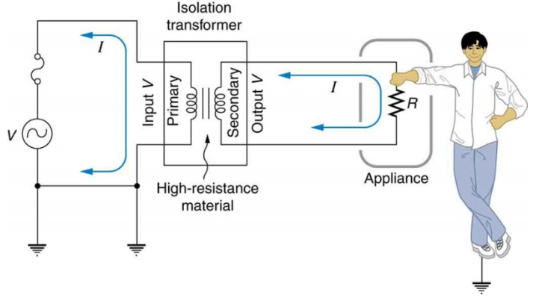**HVG**

**GND**

### 14.4Regulated Power Supply

* It is an electronic device that converts alternating current into steady direct current.
* The range of RPS is 30V/3 amp
* It consists of 3 channels. Channel 1 & 2 are of 30V/3 amp and Channel 3 is of 5V/3 amp

### **14.5 Function Generator**

* It is an electronic equipment which is used to generate standard waveforms like sine, square, ramp, triangular.
* The advantages of a function generator are cost-effective, simple to use, flexibility, amplitude and frequencies are adjustable.

## 15. GIT:

Git stands for Global Tracker Information.Git is a version control system. Git helps you keep track of code changes. Git is used to collaborate on code.

Git consists of 4 parts thoseare

* Vcs and git reports
* staging area and commits
* Branches
* Issues and pull requests

**Installation and usage:**

* Firstly we have to install the latest version of Git from the browser.
* After installation, we set up the github.
* Complete the signup process of the git
* After that we have to install the desktop app of gitup
* Here we can create a repository.
* Git operates using repositories, which are collections of files and folders that make up a project. Each repository contains the complete history of changes made to the project, including all previous versions of files..
* Commit records changes made to the files, along with a commit message that describes the purpose of the change.
* Remote repositories allow developers to collaborate, share their changes, and synchronize their work with others. They can push their local commits to a remote repository or pull changes made by others.